Glossary of Potential Projects and
Management Actions

Groundwater Demand Reduction
Crop idling (Fallowing) — This represents the temporary or permanent fallowing of land previously under irrigation that results in a reduction in stresses to a water system (e.g., alternate land use must result in a reduction in water use or an enhancement of water quality, or both).

Groundwater pumping allocation (metering, markets, etc)
The sustainable yield for a basin or Management Area would be allocated on a per acre basis. Landowners would have the authorization to pump up to the per acre limit. Typically, pumping allocations would not be sufficient to meet the crop needs. Meters would be required to ensure that pumping does not exceed acceptable amounts. Implementation options include assessing a fee for pumping above the allocation. Funds would be used for other projects that offset pumping above the allocation. Another option includes marketing allocation within the basin or Management Area. Landowners could forgo using a portion of their allocation and make their allocation available to others within the basin.

Pressure regulated sprinklers
Pressure regulated sprinklers can significantly reduce misting and fogging. This means that water is not wasted due to evaporation or being blown away, which can result in considerable water savings.

Grey water systems (catchment)
Greywater systems filter water coming out of bathtubs and washing machines from the home for use again. Additionally, water from a bath or a shower is recycled rather than flowing directly into a sewer or a septic system.

Automatic water metering (urban)
Gives near real-time reading that are accurate and not estimated. Perfects the billing process. Accurately and clearly tracks the water usage of all clients.

Rain capture
Water supplies can be augmented by capturing rainwater for later use on landscape and gardens.

Non-native vegetation removal
Removal of non-native vegetation would reduce the water demand.

Water efficient appliances (urban)
Water efficient appliances would reduce the urban water demand. During drought periods, water purveyors had provided rebates for certain water efficient appliances to customers

Moratorium on artificial lakes
Most artificial lakes are created from groundwater pumping. Artificial lakes are used for recreational activities. There are a number (unknown) artificial lakes in Butte County. New artificial lakes require a use permit from the Butte County Department of Development Services.

Swimming pool regulations
Regulation of swimming pools would be under the authority of the applicable land use agency.

Groundwater Recharge
Natural recharge — Replenishment of an aquifer generally from snowmelt and runoff, through seepage from the surface. Recharge of an aquifer that occurs without human interference — also referred to as unintentional recharge.

Recharge basin — A surface facility constructed to infiltrate surface water into a groundwater basin. Recharge basins are frequently used to recharge unconfined aquifers. Water is spread over the surface of a basin or pond in order to increase the quantity of water infiltrating into the ground and then percolating to the water table. Recharge basins concentrate a large volume of infiltrating water on the surface. As a result, a groundwater mound forms beneath the basin.

Field Flooding
A recharge project that involves flooding agricultural fields during the non-growing season.

Flood-Managed Aquifer Recharge (Flood-MAR) is an integrated and voluntary resource management strategy that uses flood water resulting from, or in anticipation of, rainfall or snow melt for managed aquifer recharge (MAR) on agricultural lands and working landscapes, including but not limited to refuges, floodplains, and flood bypasses. Flood-MAR can be implemented at multiple scales, from individual landowners diverting flood water with existing infrastructure, to using extensive detention/recharge areas and modernizing flood management infrastructure/operations. https://water.ca.gov/Programs/All-Programs/Flood-MAR

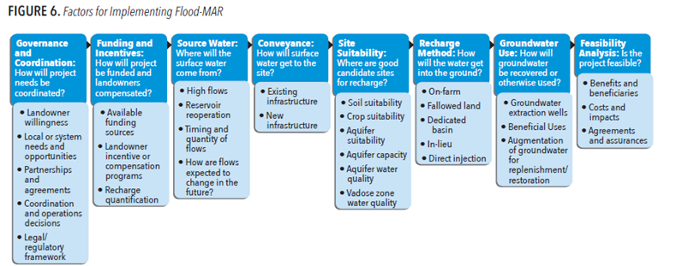

In-lieu recharge — The practice of providing surplus surface water to historical groundwater users, thereby leaving groundwater in storage for later use.
Injection wells — Injection wells are used primarily to recharge confined aquifers. The design of an injection well for artificial recharge is similar to that of a water supply well. The principal difference is that water flows from the injection well into the surrounding aquifer under either a gravity head or a head maintained by an injection pump.
Low-impact development (LID) — LID uses site design and stormwater management to maintain the site’s pre-development runoff rates and volumes. Design techniques filtrate, filter, store, evaporate, and detain runoff close to the source of rainfall. LID can be used to benefit water quality and to address the modifications to the hydrologic cycle, and it can be a means to augment local water supply through either infiltration or water harvesting. LID is seen in California as an alternative to conventional stormwater management.

Watershed management
Improved watershed management primarily through forest management and restoration can increase inflow from upper watersheds and increase streamflow and recharge.

Groundwater banks — Consists of water that is “banked” during wet or above-normal water years. The water to be banked is provided by the entity that will receive the water in times of need. Although transfers or exchanges may be needed to get the water to the bank and from the bank to the water user, groundwater banks are not transfers in the typical sense. The water user stores water for future use; this is not a sale or lease of water rights. It is typical for fees to apply to the use of groundwater banks.

Recycling
Recycled water — Volume of water that, as a result of treatment of waste, is suitable for a direct beneficial use or a controlled use, which would not otherwise occur. It includes wastewater treated, stored, distributed, and reused or recirculated for beneficial use.

Water recycling — (1) The process of treating wastewater for beneficial use, storing and distributing recycled water, and the actual use of recycled water; (2) the reuse or recirculation of water through the same series of processes, pipes, or vessels more than once by one user, often without treatment between uses, such as in cooling towers or cascading uses within an industry where the wastewater from one process is the source water for another process. Types of water recycling include “water reuse” and “water scalping”.

Mitigation
Well screen depth regulations
Depending upon the hydrogeology in a specific location, regulating the well screen depth can avoid drawing groundwater that would impact shallow wells or interconnected streams.

Groundwater contamination clean up (emerging contaminants)
The clean-up of contaminated groundwater can increase the available groundwater to meet local demand.

