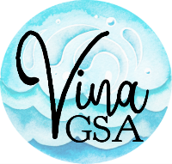

STAKEHOLDER ADVISORY COMMITTEE (SHAC)

NOTICE OF CANCELLATION OF
OCTOBER MEETING

The October 25, 2023 Vina GSA Stakeholder Advisory Committee meeting is cancelled.

Unless otherwise cancelled or rescheduled, the next Vina GSA SHAC meeting will be at 9:00 a.m. on February 28, 2024 at a location to be determined.

Posted: October 13, 2023
Vina GSA website
Prior to: 9:00 a.m. on 10/25/23

