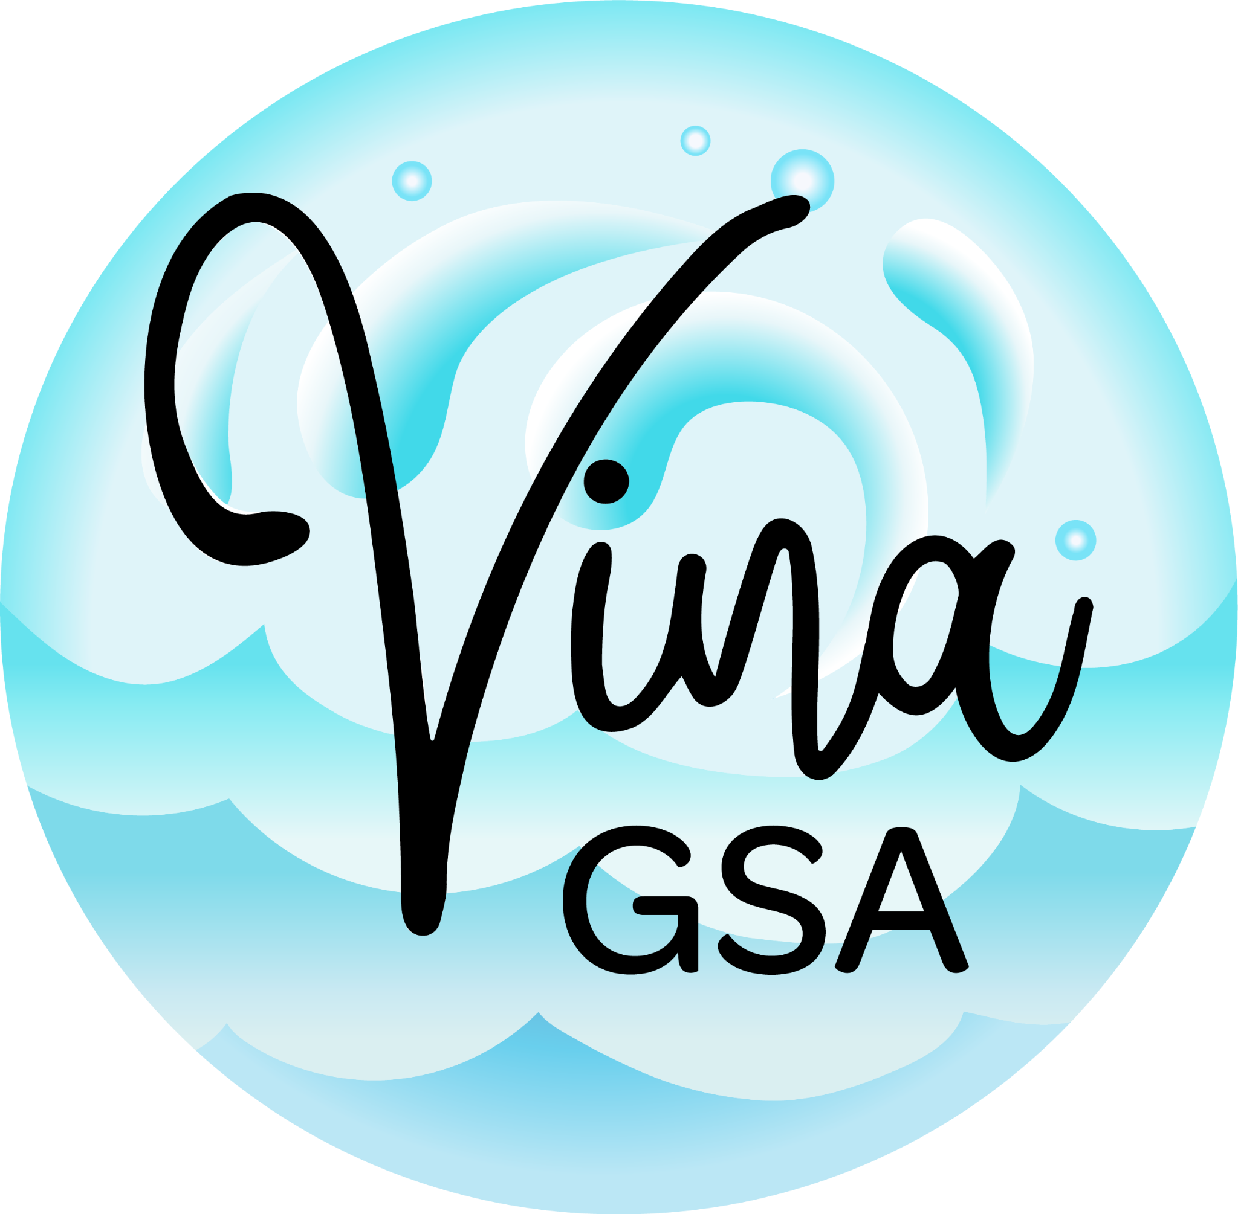
VINA GROUNDWATER SUSTAINABILITY AGENCY

NOTICE OF CANCELLATION
Vina GSA Stakeholder Advisory Committee (SHAC) Meeting
Wednesday, August 26, 2026
Please be advised that the Vina Groundwater Sustainability Agency Stakeholder Advisory Committee (SHAC) meeting scheduled for Wednesday, August 26, 2026, at Chico City Council Chamber, Conference Room #1, 421 Main Street, Chico, has been canceled.
No SHAC meeting will be held on August 26, 2026.
Notice of the next SHAC meeting will be posted and distributed in accordance with applicable public meeting requirements.
Posted: August 24, 2026

