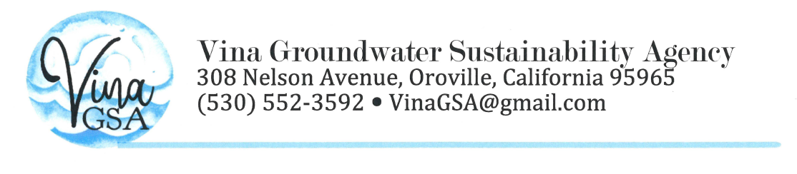
CORRESPONDENCE
VINA STAKEHOLDER ADVISORY COMMITTEE (12/15/20)
----Original Message-----
From: "sgmps@DWR" <sgmps@WATER.CA.GOV>
Subject: SGMO NEWS: Updated C2VSimFG Available
Date: December 8, 2020 at 1:22:36 PM PST
To: DWR_SGMP@LISTSERVICE.CNRA.CA.GOV

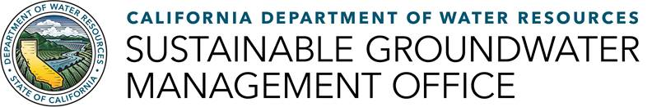
Updated Version of Central Valley Groundwater-Surface Water Model Now Available
The Department of Water Resources (DWR) has released an updated version of the Fine-Grid California Central Valley Groundwater-Surface Water Simulation (C2VSimFG) model, which can be used by Groundwater Sustainability Agencies developing water budgets for their Groundwater Sustainability Plans.
C2VSimFG Version 1.0 is a historical simulation model designed to estimate regional groundwater flow throughout the Central Valley. C2VSimFG is an integrated hydrologic model application and uses demand estimates from land use and population to calculate spatially distributed groundwater pumping and recharge estimates. The updated tool includes calibration of aquifer properties and documentation.
DWR will host informational webinars and a multi-day training event on C2VSimFG Version 1.0 in winter 2021. More information will be available when these events are scheduled.
To download the model files and documentation or to make comments or suggestions for future updates, visit DWR’s Data and Tools webpage, go to the Modeling tab, and click on Modeling Applications.

