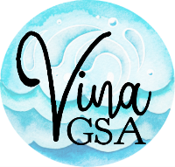

VINA GROUNDWATER SUSTAINABILITY AGENCY

NOTICE OF CANCELLATION OF MEETING

The November 8, 2023 Vina Groundwater Sustainability Agency Board meeting is cancelled.

Unless otherwise cancelled or rescheduled, the next Vina Groundwater Sustainability Agency meeting will be at 5:30 p.m. on April 10, 2024 in the Council Chamber Building at 421 Main Street Chico CA.

Posted: October 13, 2023
Posting Location: City Council Chamber Bldg, 421 Main Street, Chico CA
Prior to: 5:30 p.m. on 11/08/23

