Meeting Brief
- The Vina Stakeholder Advisory Committee (SHAC) met virtually on October 20, 2020.
- Updates: The SHAC received an update from the Vina GSA Management Committee and reviewed the previous meeting notes. The Consensus Building Institute (CBI) presented a brief overview of ongoing inter-basin coordination efforts in the Northern Sacramento Valley [access here] and discussed next steps in the process and future opportunities for SHAC involvement.
- Project and Management Actions (PMA): P. Gosselin (Butte County) gave an overview presentation on scope of PMAs and examples of the types of PMAs found in other groundwater sustainability plans (GSP) [access memo | access slides]. The SHAC had an initial (“brainstorming”) discussion of PMAs, using an online tool, Miro Board, to gather ideas, concepts, and information needs [access Miro board]. The purpose of the initial discussion was to begin the process of developing recommendations to the Vina Groundwater Sustainability Agency (GSA).
- Groundwater Dependent Ecosystems (GDEs): K. Peterson (Butte County) provided an overview presentation describing GDEs, approach, status of effort & next steps. SHAC members asked clarifying questions and provided feedback. The public had an opportunity to comment.
- Next Meeting: The SHAC will meet again via video conference on November 17, 2020 from 9:00-12:00.

Action Items
Item | Lead | Completion
- Make revisions to September 15th meeting summary and recirculate with the SHAC with tracked changes (including B. Smith’s vote and Cheri’s input). | CBI | By next meeting (11/17)
- Follow up with Joshua Pierce about his participation on the SHAC. | CBI | Upon completion
- Post on website North Sacramento Valley (NSV) inter-basin coordination slides. | CBI and Vina GSA Management Committee | Complete. Access here.
- Provide Vina FSS task order to SHAC. | Butte County | Upon completion
- Share template documents for inter-basin coordination with the SHAC. | CBI | Upon completion
- Include inter-basin coordination updates to December SHAC meeting agenda. | CBI and Vina GSA Management Committee | Upon completion
- Provide links to SVSIM, C2VSIM and BBGM models. | C.Buck/ Butte County | By next SHAC meeting (11/17)

Summary
The Vina SHAC met on October 20, 2020 via video conference, as a result of COVID-19. 29 participants attended, including Vina SHAC members, GSA member agency staff, a technical consultant, and members of the public. Below is a summary of key themes and next steps discussed at the meeting. This document is not intended to be a meeting transcript. Rather, it focuses on the main points covered during the group’s discussions.

Introductions & Agenda Review
The SHAC members, facilitator, technical consulting teams, and staff introduced themselves. The facilitator gave a brief overview of the agenda.

Public Comment for Items Not on the Agenda
A SHAC member inquired about Joshua Pierce, domestic well representative on the SHAC, who has missed three consecutive meetings. CBI will reach out to him again and report back to the SHAC.

3. Vina GSA Management Committee Reports
- Vina GSA Board Updates: The Vina GSA Board met on October 14 at 5:30pm to review housekeeping issues (budget, minutes, financial status, etc.), and receive an update on Draft Basin Setting chapter public comments received. The meeting recording (audio and video) and supporting materials can be found at the Vina GSA website (access here). Board members were presented with information about the suggested updates to the Vina SHAC Charter. Legal counsel is still reviewing proposed changes, and the charter will be brought back to the Vina SHAC at the November meeting. In addition, Facilitation Support Services (FSS) for the Vina Subbasin are expiring at the end of the calendar year, and the Vina GSA has submitted a request to continue FSS for next year. Lastly, the Vina GSA Board submitted a letter to state authorities requesting an extension for Groundwater Sustainability Plan (GSP) submittal, due to current public engagement challenges and limitations. The GSA has not received a response from the administration.
- Inter-basin Coordination Updates [access here]: Representatives from the Antelope, Bowman, Butte, Colusa, Corning, Los Molinos, Red Bluff, Vina, and Wyandotte Creek subbasins have met three times to discuss inter-basin coordination. The first two meetings included GSA staff only from Butte, Colusa, Glenn, and Tehama counties, and the third meeting included technical consulting teams. The various subbasins have agreed to share technical information and reconvene in early December. Inter-basin coordination efforts have focused on creating tools to foster general and technical information exchange, such as a technical information-sharing template. Each subbasin’s consulting team will fill the template, in order to identify similarities and differences related to modeling approaches, cross-boundary flows, stream-aquifer interactions, and common hydrogeologic understanding. Participants will revisit conversations about Sustainable Management Criteria and Monitoring Networks next year. CBI will provide inter-basin coordination updates on a regular basis moving forward.

Discussion | Public Comment
- A member of the public inquired about CBI’s Facilitation Support Services contract. T. Carlone (CBI Facilitator) clarified CBI is on a roster of independent third-party facilitators, funded through DWR Facilitation Support Services. CBI’s scope of services in the Vina Subbasin includes a series of tasks. These tasks include Stakeholder Advisory Committee (SHAC) support and Inter-basin Coordination.
- In response to a question about DWR’s role in inter-basin coordination, P. Gosselin (Butte County) clarified two state agencies have a role under the Sustainable Groundwater Management Act (SGMA): the State Water Resources Control Board (State Water Board) enforces compliance, while the DWR provides guidance and technical support services, such as GSP review, monitoring well installation, facilitation support, etc. This assistance is funded under Proposition 1 and 68, and is administered by DWR.

Outcomes & Next Steps | Vina GSA Management Committee Reports
- CBI will share inter-basin coordination documents with the SHAC, including the technical information-sharing template, the issue framing document, and previous meeting summaries.
- CBI/Butte County will share Vina FSS task order to SHAC.
- The Vina GSA Management Committee will share more information about the Department of Water Resources (DWR) subbasin prioritization process for subbasins.

4. Meeting Notes Review & Consideration
The SHAC reviewed the meeting notes from the 9/15/20 SHAC Meeting [access here].

Outcomes & Next Steps |Meeting Notes Review & Consideration
- The facilitation team will review the meeting recording to revise the September 15th meeting summary and recirculate with the SHAC with tracked changes (including B. Smith’s vote and tracking C. Chastain’s input).
- The SHAC will revisit meeting notes’ approval during the next meeting.

8. Projects and Management Actions (PMA)
The SHAC had an initial (“brainstorming”) discussion of PMAs. P. Gosselin (Butte County) gave a brief overview presentation on scope of PMAs and of examples of the types of PMAs included in other submitted groundwater sustainability plans (GSPs). Many GSPs include a broad set of PMAs related to achieving measurable objectives, other management actions and filling data gaps (e.g., shallow monitoring wells) [access memo | access slides]. SHAC members and members of the public asked clarifying questions. Following the presentation, the facilitation team introduced an innovative online tool, Miro Board, to guide the SHAC discussion and gather SHAC members’ ideas, concepts, and information needs [access Miro board]. The purpose of the initial discussion was to begin the process of developing recommendations to the Vina Groundwater Sustainability Agency (GSA).

Questions and Discussion | PMAs
- A SHAC member emphasized the need to explore the efficacy of different recharge programs per aquifer zone. In his perspective, the ideas presented are too focused on augmenting supplies and not enough on demand management. Further, this SHAC member referred to the 1978 recharge study. P. Gosselin clarified that under SGMA, GSAs are required to avoid surface water depletion. Further, efficiency will be analyzed carefully during the PMA process.
- Another SHAC member highlighted the need to review laws and legal implications of management actions to consider.

PMA “Brainstorming”

Figure 1. Sticky Note Capture from Initial PMA Brainstorm using Miro Board
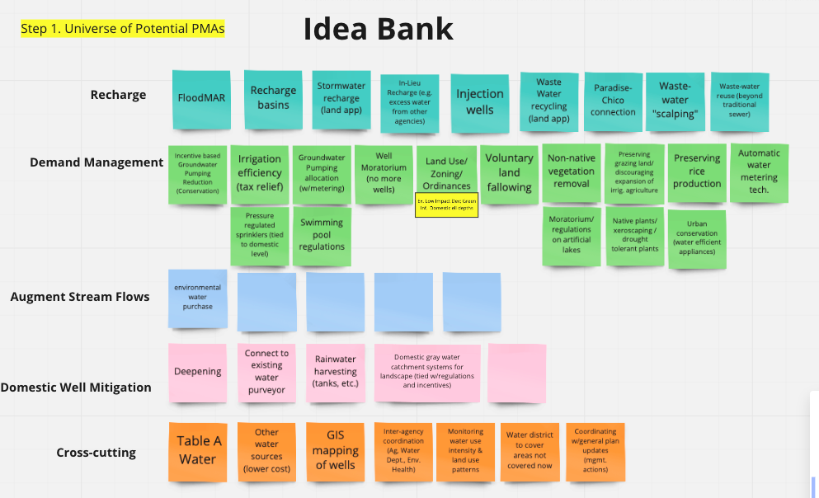

Table 1. List of PMAs from other GSPs and from SHAC Initial Brainstorm
Type | Ideas and Concepts
Recharge | - FloodMAR  - Recharge basins  - Stormwater recharge (land application)  - In-lieu recharge  - Injection wells  - Paradise-Chico Connection  - Wastewater recycling (land application)  - Wastewater reuse (beyond traditional sewer)  - Wastewater “scalping”
Demand Management | - Incentive-based groundwater pumping reductions  - Irrigation efficiency (tax relief)  - Groundwater pumping allocations (with metering)  - Well moratorium  - Land-use/zoning ordinances (e.g. low impact development)  - Voluntary land fallowing  - Non-native vegetation removal  - Preserving grazing lands – discouraging expansion of irrigated ag.  - Preserving rice production  - Automatic water metering technology  - Encouraging native plants, drought-tolerant plants, and xeriscaping  - Pressure regulated sprinklers  - Swimming pool regulations  - Moratorium on artificial lakes  - Promoting urban conservation / water efficient appliances
Augment Stream Flow | - Environmental water purchase
Domestic Well Mitigation | - Deepening wells  - Connecting to existing water purveyors  - Rainwater harvesting / tanks  - Domestic greywater catching systems for landscapes
Other/ Cross-cutting projects | - Table A Water  - Other (lower cost) water sources  - GIS mapping of wells  - Greater inter-agency coordination  - Monitoring water use intensity and land use panel  - Expansion of water districts to “white areas”  - Coordination with general plan updates

Information Needs:
As part of the “brainstorm” exercise, SHAC members identified information needs to guide PMA discussions moving forward:
- General Plan: agricultural needs and water use patterns
- Legal implications associated with PMAs, relevant when evaluating ideas
- Existing land use ordinances, related to rainwater harvesting, artificial lakes, swimming pools, wastewater reuse, etc.
- Efficacy of recharge programs presented (existing studies at a regional level)
- Updated model techniques (SVSIM, C2VSIM and BBGM models)
- Existing inter-basin agreements and guidelines [Article 8 §357.2 (b)]
- Impact of other subbasin’s land use decisions on Vina

Outcomes & Next steps | PMAs
- CBI and the Vina GSA Management Committee will summarize a list of the PMAs identified and share resources to address information needs identified.
- The Vina SHAC will continue PMA conversation to gauge level of agreements and interest.

Groundwater Dependent Ecosystems (GDEs)
K. Peterson (Butte County) provided an overview presentation describing GDEs, their importance, and SGMA requirements associated with GDEs [Access slides]. GDEs are communities or species that depend on groundwater emerging from aquifers or on groundwater occurring near the surface. GDEs are considered beneficial users of groundwater and can be affected by chronic lowering of groundwater levels and by surface water depletion. SGMA requires GSAs to identify GDEs within the basin and assess the impacts to those GDEs, as specified in Section 353.2 [§ 354.16. Groundwater Conditions], utilizing DWR data or the best available information. In addition, K. Peterson outlined the approach followed to identify GDEs in the Vina Subbasin, the status of effort and an overview of next steps. SHAC members asked clarifying questions and provided feedback. The public had an opportunity to comment.

Discussion | GDEs
- GDE Working Group: a GDE Working Group (WG) was formed to provide feedback on the approach to GDE analysis. The WG met in July and October 2020. WG feedback included representative shallow monitoring network, urban forests, valley oak rooting depth, adaptive incorporation of new information, and the approach to assess connections to groundwater. J. Brobeck, member of the SHAC and the GDE Working Group, requested more information regarding the status of the valley oak root depth not directly near streams and urban forest. K. Peterson responded that the GSA took a conservative approach to include all of the GDEs into future analyses. The SHAC will be the venue to discuss GDEs moving forward.
- Another SHAC member asked whether the WG was a subcommittee of the SHAC. K. Peterson clarified that the WG was not a subcommittee of the SHAC, rather a group composed of representatives from multiple subbasins, with strong interest in the topic, and technical background to provide feedback on the approach followed to identify and assess GDEs.
- P. Gosselin stated the Vina GSA is on track because the GSA will need to consider GDEs throughout GSP development, as beneficial users. GDE information will be used in technical analyses by the consultants for SMC discussions.

Outcomes & Next Steps | GDEs
- The dataset with conclusions for all ~4,600 GDEs identified were provided to the consulting teams.
- GDEs will be considered and further refined when considering Sustainable Management Criteria (SMC), monitoring networks, and groundwater level discussions.
- GDWs will be incorporated into the draft Basin Setting GSP chapter.

Next Steps
The Vina SHAC will reconvene on November 17, 2020 from 9am-12pm via videoconferencing.

Participants
Participant |  | Representation/Affiliation | Present
Vina Stakeholder Advisory Committee (SHAC) Members
Anne Dawson |  | Domestic well user | Y
Bruce Smith |  | Business representative | Y
Cheri Chastain |  | CSU Chico | Y
Christopher Madden |  | Butte College | Y
Gary Cole |  | Agricultural well user | Y
George Barber |  | California Water Service | Y
Greg Sohnrey |  | Agricultural well user | Y
James Brobeck |  | Environmental representative | Y
Joshua Pierce |  | Domestic well user | N
Samantha Lewis |  | Agricultural well user | Y
Groundwater Sustainability Agency (GSA) Member Agency Staff
Christina Buck |  | Butte County | Y
Paul Gosselin |  | Butte County | Y
Kelly Peterson |  | Butte County | Y
Linda Herman |  | City of Chico | Y
Jeff Carter |  | Durham Irrigation District | N
Kamie Loeser |  | Durham Irrigation District | Y
Colin Klinesteker |  | Mechoopda Indian Tribe | Y
Technical Consultants
Joe Turner | Geosyntec |  | Y
Amer Hussain | Geosyntec |  | Y
Facilitator
Tania Carlone |  | Consensus Building Institute | Y
Mariana Rivera-Torres |  | Consensus Building Institute | Y
Approximately eight members of the public attended the meeting.

